Kaneki Ken

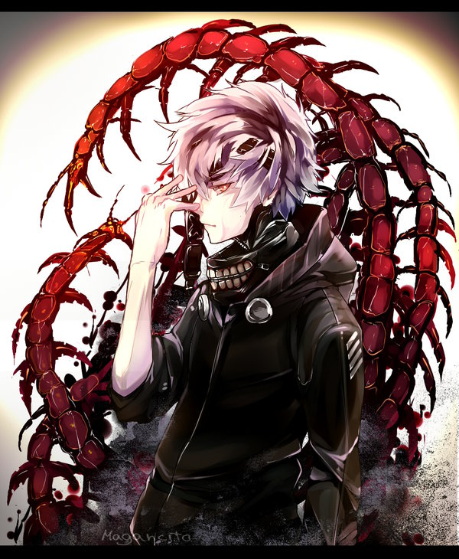

Race: Ghoul Alignment: Chaotic Good Anime: Tokyo Ghoul

1 – Madness: Taking damage fills madness. Each point of health lost counts for 1 point. If he reaches 100 madness, Kaneki evolves.

Active: If activated, Kaneki has a chance to Evolve equal to his current madness.

2 – Rinkaku: Can be used twice per round, as long as the attack is a different type (Can’t use two slashes or Pierces etc.)

1) Slash - Attacks up to three enemies, dealing 15 ranged damage to them.

2) Pierce - Attacks a single enemy piercing 50% of their defenses and dealing 35 melee damage.

3) Immobilize - Deals 10 damage and prevents the enemy from performing melee attacks this and next turn.

3 – Resist: Uses his kagune defensively to block one attack this turn. The madness is still filled as if the attack hit. If the block was ignored or bypassed, he gains 10 more madness.

4 – Haste: Increases the speed of an attack that this is used with by 1 and its damage by 10. If the enemy that was targeted used an attack too, Kaneki's attack is cancelled completely. Haste, relativistic.

5 – Regenerate: Regenerates 10hp at the end of each round. Passive

6 – Pain Tolerance: Any damage taken this turn is used for the madness meter with double effect. If he takes 30 or more damage, Kaneki also heals for 10hp. If he dies, Kaneki doesn’t heal. Relativistic.

Ultimate – Evolve: When he reaches 100 madness, Kaneki changes into his next stage and heals back to 50 hp if below. The first is White Ghoul. His abilities in this mode are as follows:

1 – Madness: Taking damage fills madness. Each point of health lost counts for 1 point. If he reaches 100 madness, Kaneki evolves.

Active: If activated, Kaneki has a chance to Evolve equal to his current madness.

2 – Rinkaku:

1) Slash – deals 20 damage to up to 5 enemies and applies a bleed effect on them. They bleed for 2 turns, for 5 damage per turn.

2) Pierce and Immobilize – Deals 40 damage and pierces half of the enemies’ defenses. If the enemy didn’t attack this turn, they are immobilized in the next one, if they did, the attack is cancelled if it was melee.

3 – Lunge: Propels into the air, dodging all attacks this turn. They still count for building madness, though the damage they would have dealt is disregarded. Hits first.

4 – Haste: Increases the speed of an attack that this is used with and its damage by 10. If the enemy that was targeted used an attack too, the damage of their attack is doubled. Haste, Relativistic.

5 – Regeneration: Regenerates 20hp at the end of each round. Passive

6 – Centipedes: Any damage taken this turn is ignored unless fatal. The madness fills twice as much from all the ignored damage. Relativistic.

Ultimate – Evolve: When he reaches 100 madness, Kaneki changes into his next stage, also healing back to 50 hp if below. The final is Kakuja. His abilities in this mode are as follows:

1 – Howl: Stuns all enemies in this turn.

2 – Kagune:

1) Rinkaku – Deals 50 ranged damage to a single enemy. Hits before hits first.

2) Bikaku – Deals 25 ranged damage to an enemy, and stuns them in the next turn.

3) Koukaku – Takes 75% less damage from melee attacks for 2 turns. Deals 20 melee damage. Hits first.

4) Ukaku – Takes 75% less damage from ranged attacks for 2 turns. Deals 20 ranged damage. Hits first.

3 – Slither: Dodges all attacks this turn and marks an enemy. If the marked enemy is successfully attacked in the next turn, they are also stunned.

4 – Haste: Increases the speed of an attack that this is used with and its damage by 15. If the enemy that was targeted used an attack too, Kaneki's attack is cancelled completely. Haste, Relativistic.

5 – Degeneration: Loses 5 hp at the end of each turn. Passive.

6 – Burst Heal: Heals for 50 hp. The degeneration damage is doubled.